**Database:**

User Table:

**User ID**, **username**, firstname, lastname, birthdate, height, gender

Daily Input Table:

*User ID*, **Input ID**, **Date**, alcohol intake, water intake, weight

CSV/JSON/Local:

Hobby recommendations, Motivational facts, Milestone

**Motivational Facts:**

[**https://www.awakenthegreatnesswithin.com/35-inspirational-quotes-on-progress/**](https://www.awakenthegreatnesswithin.com/35-inspirational-quotes-on-progress/)

[**https://www.goodreads.com/quotes/1152042-it-s-not-about-how-hard-you-hit-it-s-about-how**](https://www.goodreads.com/quotes/1152042-it-s-not-about-how-hard-you-hit-it-s-about-how)

[**https://www.ashwoodrecovery.com/blog/15-benefits-quit-drinking-alcohol/**](https://www.ashwoodrecovery.com/blog/15-benefits-quit-drinking-alcohol/)

“If there is no struggle, there is no progress.” Frederick Douglass

## “Without continual growth and progress, such words as improvement, achievement, and success have no meaning.” Benjamin Franklin

# “It's not about how hard you hit. It's about how hard you can get hit and keep moving forward. How much you can take and keep moving forward.” - Rocky Balboa

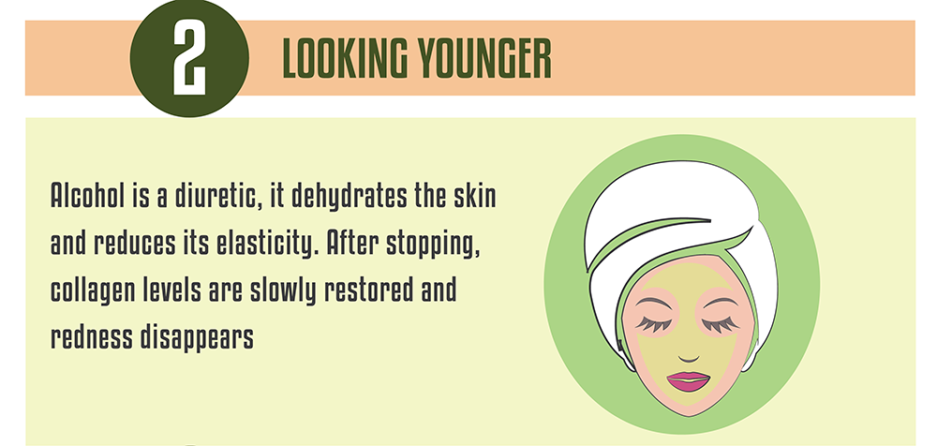

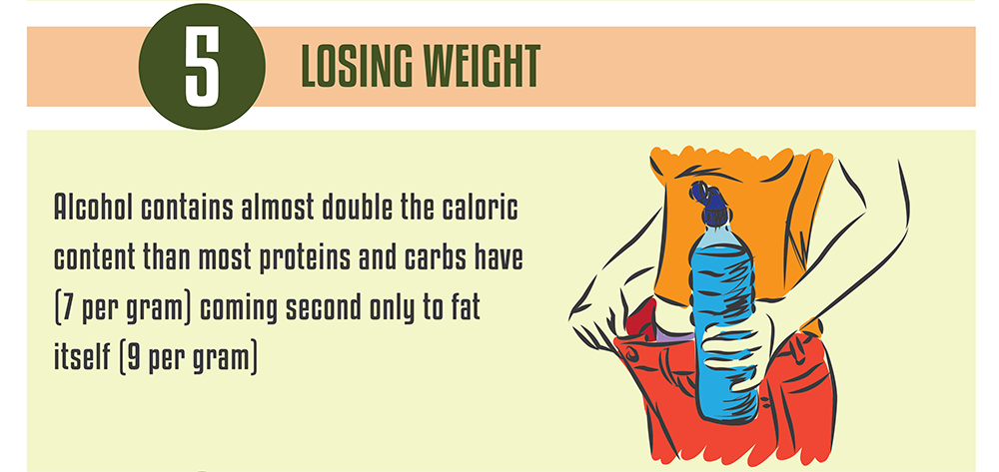

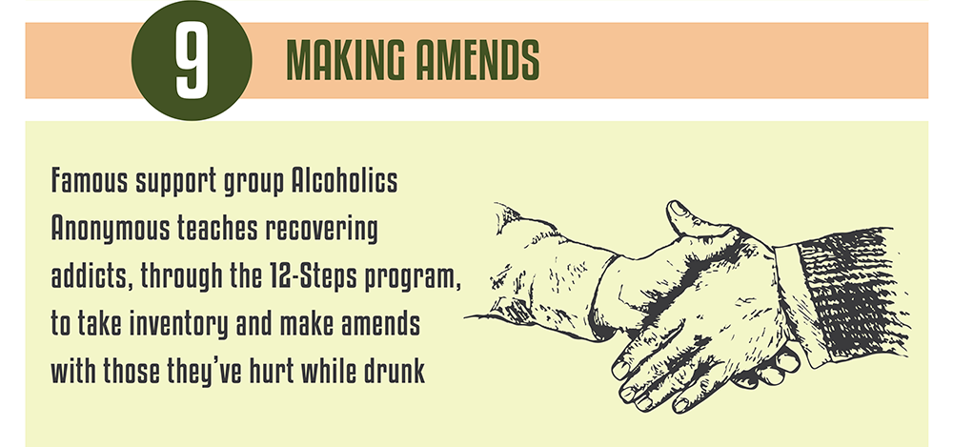

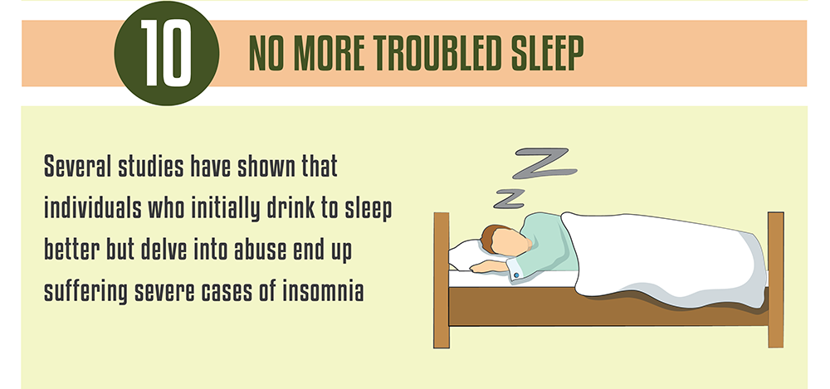

**The** [**CDC**](https://www.cdc.gov/cancer/alcohol/index.htm) **reports that the less you drink, the less your risk for cancer is.**